User Testing Questions

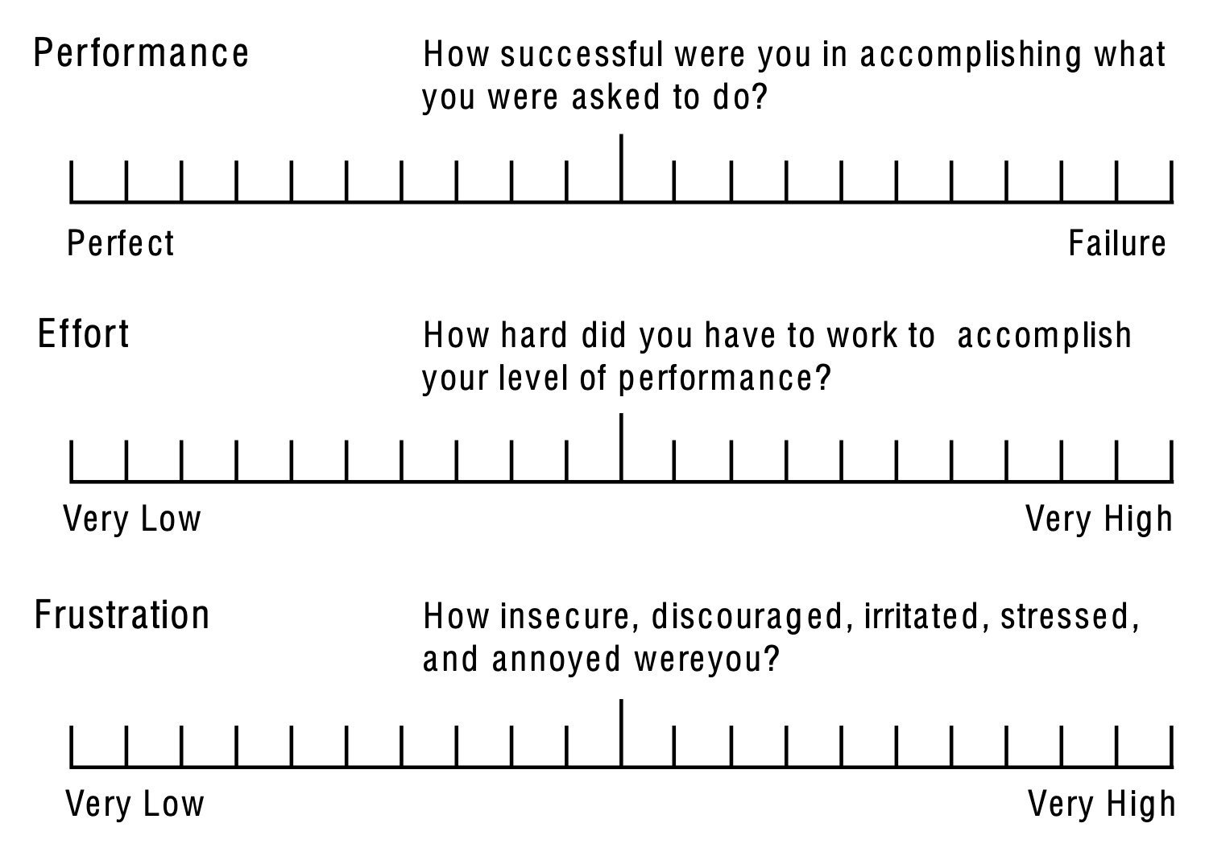

Editor to do’s

* Add hotspot
* Add description/photo/video
* Start application
* Import config
* Start application
* Add hotspot
* Add description/photo/video
* Save
* Export

**Strongly disagree Strongly Agree**

**1 2 3 4 5**

Editor Questions

1. I thought the editor was easy to use
2. I think I would need the support of a technical person to be able to use the editor
   1. Which aspects were overcomplicated?
3. I would imagine most people would learn how to use the editor very quickly
4. I felt very confident in using the editor
5. I needed to learn a lot of things before I could get going with the editor

Hotspot questions

1. I would understand the systems purpose without the use of prompts
2. I could imagine this being in use in an interactive exhibit
   1. What changes would help in making this feel more like an interactive exhibit?
3. The animations feel janky and affected my experience
   1. What changes would you like to see to the animations?
4. The information displayed was easy to read
   1. What aspects made it hard to read the information?

Are there any other changes you would like to see if you were to adopt this system?